REPORT FOR THE ATTENTION OF UNITED NATIONS VOLUNTEER DEVELOPMENT PROGRAMME (UNDP) ON IMPLEMENTATION OF ACTIVITIES ON DISASTER RISK MANAGEMENT IN SIERRA LEONE
BY
UNITED NATIONS DISASTER RISK MANAGEMENT PROJECT AND THE DISASTER MANAGEMENT DEPARTMENT
OFFICE OF NATIONAL SECURITY
2018

1: 0 BACKGROUND
United Nations Development Programme (UNDP) has been supporting the Office of National Security (ONS) in the management of National Emergencies. Most of the support has been in terms of building the national capacity of state institutions and the development of critical national documents like the National Hazard Profile and the National Disaster Risk Management Policy. In terms of interfacing with other institutions and building community resilience, the UNDP has provided the much needed support towards District Disaster Management Committees (DDMCs) in all fourteen Districts with the exception of the newly created district including Karena in North-West and Falaba in the extreme north of the country.
In 2018, the UNDP supported the Office of National Security with the sum of Three Hundred and Million Leones (Le372,000, 000) for its activities. As a logical step forward the support to the ONS was preceded by the development of an annual work plan agreed by the two institutions. For this year’s report it is evident that four key important areas were cardinal in taking the National DRM programmes forward. The areas are Disaster Management Schools and colleges outreach programmes, District Disaster Management Committees (DDMCs, Community Volunteer’s programme and the commemoration of International Day for Disaster Risk Reduction.
These project activities are supported with a national UNV -Project officer -Margarette S Dauda since the inception of the Disaster Risk Project Management in coordinating activities and facilitating capacity building to implementing partners and staff.
Under my supervision and mandate ,below were the activities implemented according to outcomes of the project:
Activity 5.1.13. Develop and implement awareness campaign for schools and colleges
As a step towards building knowledge of academic institutions and other centres of learning in the country on hazards, vulnerabilities and risk in the country, we prioritized schools and some selected colleges in addressing the aforementioned. For the implementation of this year’s programme, priority was placed upon engaging schools and colleges in North, south and the east of the country. Facilitators were drawn from the Sierra Leone Red Cross Society (SLRCS) who travelled with the team across the country. The engagements were characterised by focus group discussion whilst other were done in the form of professional and academic presentations. There was enough room for interaction among the participants. Some practical exercises based upon community hazards, development of contingency plans, risk mapping and vulnerability analysis were done. It is noted that this program was followed by an effective radio discussion programmes hosting students, facilitators and representatives from the Office of National Security. Feedback from members of the public was reported to be good. Some of the concerns raised by some members of the public is that the programme be repeated at least twice a year as a measure of building knowledge and resilience for school going children and measures to take to address sudden onset disasters and how to interact positively with the environment. This engagement goes a long way to reinforce disaster management schools outreach programme. Interesting to note that this exercise took place in the month of May- June 2018. At this time most of the hazards related to the raining season such as windstorm, floods and erosion were brought into the equation for discussion.
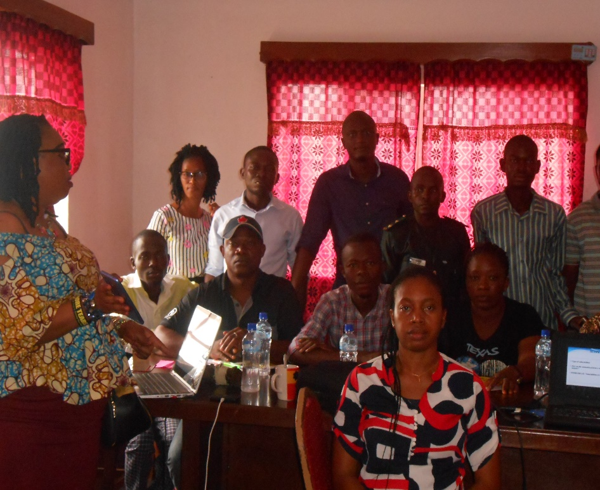
UNV-Project Officer -Margarette Dauda (left corner) facilitating on hazard mapping and mitigation with district disaster management committees in collaboration with ONS staff
Activity 5.1.7 Training of DDMC in: DRR, Preparedness, Response, Coordination, simulation activities, early warning
Since the establishment of the National Disaster Management programme, it was made clear that engagement upcountry was vital for the overall success of the programme. The UNDP in tandem with the Disaster Management Department in the Office of National Security has been cooperating on the establishment of District Disaster Management Committees across the country. Out of sixteen district in the country fourteen District Disaster Management Committees have been established with the exception of the newly created two of Karena in the North-West and Falaba in the far North of the country.
One lesson learnt over time is the poor capacity of DDMCs to prevent, mitigate or respond to disasters. Thus the need for effective capacity building .In this engagement, all sitting members of the various DDMCs were given full blown capacity building effort. It took the form of power point presentations. Topical issues are kin to their environment and people were identified followed by a logical development of methodological approach of presentation was done. The presenters were from various backgrounds based upon their professional engagement. The national hazard profile that speaks to most of the challenges that we face as a country was very useful in all of the engagement.
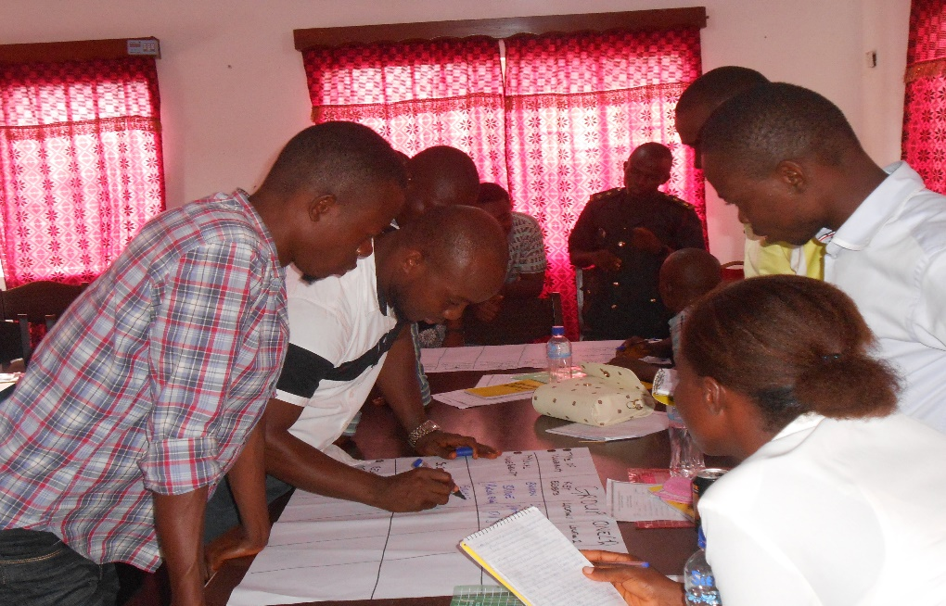
Community Risk mapping done in Kenema by volunteers /DDMCs
The engagement upcountry with the various DDMCs was preceded by mock presentations by all of the facilitators to determine their capability and depth of knowledge on the issues. This was followed by a well-planned programme of engagement with ONS coordinators upcountry. All of the participants were well engaged and briefed on the importance of the training before the arrival of the trainers. Most of the members of the DDMCs welcomed the training package and were very much appreciative of the effort that was infused into this whole programme. What was expressed by all the participants is a continuation of the programme and sharing of new information on both natural and man-made disasters.
At the end of the programme, it was acknowledged that building the knowledge of stakeholders especially in strategic and operational coordination could go a long way in addressing challenges at community level.
Activity 5.1. 7 Mobilization and training of DM volunteers
Following the massive landslide that destroyed lives and property along the sugar loaf mountain of the Western Area Peninsula Forest, the felt need for effective engagement with Disaster Management volunteers became necessary. This engagement targeted fifty(50) volunteers in all seven communities that were hard hit by the landslide and floods. The processes and procedures for engagement was done through community elders and chiefs as flood community mitigation strategy a pillar from the city mayors umbrella mitigation strategy.
It should be recalled that building resilience at community level is one fundamental strategy approved and adopted by the international and local players, the Sendai Framework of action and the entire spectrum of disaster risk management. In an attempt to contribute to this wider strategy the Disaster Management Department undertook massive awareness raising through door to door engagement.
The methodology approach in this engagement started with one day inception workshop with community stakeholders, local authorities and trained volunteers that were established after the mudslide. The essence was to discuss the objective of DRR campaign activities and strategies of implementation for community participation and ownership.
This was followed by a two day training programme of community volunteers on community based disaster risk reduction and strengthening of early warning and early response. In addition is a constructive engagement on community risk mapping and vulnerability assessment . Interesting to note that the engagement was very interactive and participatory .
Among the critical outcome is an increased knowledge on DRR and Early Warning system of the vulnerable population to enhance preventive measures by community against disasters. In a similar vain, community people were given enhanced knowledge on hazard identification, risk mapping, indexing analysis and interpretation.
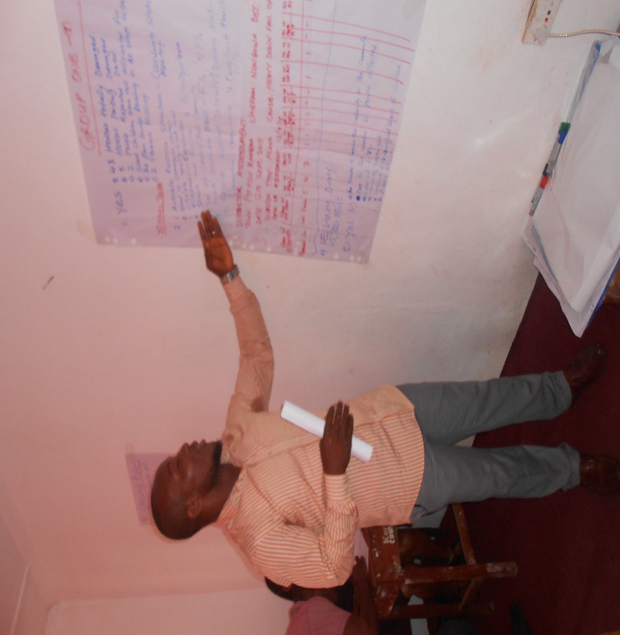
A community volunteer presenting risk /hazard mapping
On the practical note, community people including volunteers were engaged in
learning storm drain channels and gutters. This was done as a safe guard measure against the rains
Activity 5.1. C. Awareness activities on DRR - International DRR week
Government of Sierra Leone through the Office of National Security and International partners observed the International Day for Disaster Risk Reduction (IDDRR). The theme for this year’s celebration is reducing the Economic Loss to Disasters. This theme is considered appropriate against the background of the catastrophic effect of the twin disasters of landslide and flood of 14th August 2017. As a step forward in observing this day, key activities were identified by core planning group for the commemoration.
The planning team agreed to invite relevant stakeholders together to a single platform to deliver statements on the significance of this day and most specifically on the theme for 2018 celebration. In this respect the high table was occupied by the National Security Coordinator from the Office of National Security (ONS), the Representative of the United Nations Resident Coordinator (UN), the Country Director for Voluntary Service Oversea (VSO), the Honourable Minister of Social Welfare Gender and Children’s Affairs (MSWGCA) and the Representative of United Nations Development programme (UNDP).
In the key note address delivered by the Minister of Social welfare Gender and Children’s Affairs, she pointed out the need for people to interact well with the environment and strongly advised our compatriots resident in hazard prone areas especially at the sea front and up hills to move away from high risk areas to safer ground.
In the statement of the National Security Coordinator, he said the devastation caused by the Ebola Viral Disease(EVD) on our national economy was citied out and crippling of the economy especially closing down of mining activities, educational institutions, capital flight due to closing down of factories and small scale businesses.
The Country Director for Voluntary Service Oversea commended government for the bold steps taken in observing the International Day for Disaster Risk Reduction and noted the high level cooperation and collaboration between his organisation and the Office of National Security. He specifically noted the support given to ONS in terms of volunteer corps in six major districts of the country and stated that they are the first responders to localized national emergencies. He observed the development of training module for volunteers and how it has helped the level of preparedness of communities cannot be overemphasized.
On the part of the Representative for the United Nations Resident Coordinators, she observed that effective synergy had long since existed between UN agencies in the country and Government especially in terms of support for emergencies. She went further to state that capacity building of the country in terms of preparedness has been an approach by the UN. She said, with effective preparedness, disasters may occur but the economic severity will be on a limited scale. The representative of the UN Resident Coordinator mentioned support in terms of developing strategic national documents like the National DRM policy and the Revised National Hazard profile. She promised to continue to leverage support to the government and people of Sierra Leone.
The commemoration of IDRR brought together volunteers from six main district for the first time, representatives from Ministries, Departments and Agencies (MDAs) International Partners , teachers, school pupils and community representatives. Everybody that attended the programme was given a T-shirt with ONS and VSO emblem, an inscription stating the importance of the day . The climax of the event was followed by the launch of a training manual by the Minister of Social Welfare Gender and Children’s Affairs.
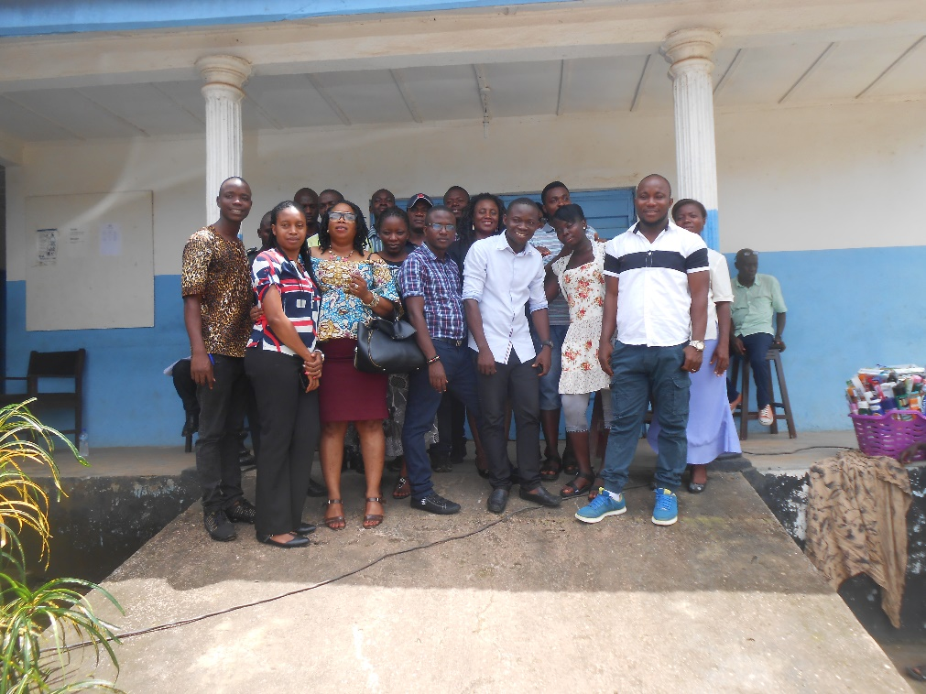
DDMCs/Volunteers from different districts-Kenema ,Bo, Kono, Pujehun.
Significant to note is that the success of this celebration was as a result of budgetary support by Voluntary Service Oversea (VSO) which supported in hiring of the hall (Family Kingdom), breakfast and lunch for over 200 participants, buying and printing of T- shirts ,DSA and transport allowance for volunteers that travelled from up country ,printing of banner and media. UNDP also made budgetary support with T-shirts for school children banner, transport refund for school children teachers and tea break.
The commemoration was followed by media engagement by Director, Disaster management in which the public was informed about the importance of the day and significance of the theme for the commemoration.
In a summary the commemoration was well attended and attracted attention from government, local community and International partners.
CONCLUSION
It is worthy of note to state that engagement and support from UNDP to Government of Sierra Leone through the Office of National Security partially helped to reduce the occurrence of any major incident in the country at large in 2018.
Though the capacity of national institutions is not fully up to standard, yet the contribution of UNDP to programmatic activities at community and national levels has been of serious commendation by leaders of DDMCs and other players. It is hopeful that this relationship will be maintained till government is able to reduce the occurrence and severity of disasters at national and local levels.
CHALLENGES
- There are Conflicting mandates of Ministries, departments and Agencies -MDAs to undertake indicative activities
- There is a high staff turnover at the disaster management department and local councils affect institutional memory for sustained support within the DDMCs after the elections
- There is lack of knowledge to priotize project activities and planning
-DRM policy was not popularized and lauch because of clarify to review mandates of the proposed disaster agency to be reviewed
-Solutions
-Staff /project officers should be maintained for longer period
-Conduct meeting with ONS management on future implementation with partners on UN procurement issues
-Clear mandates should be define to the MDAs

